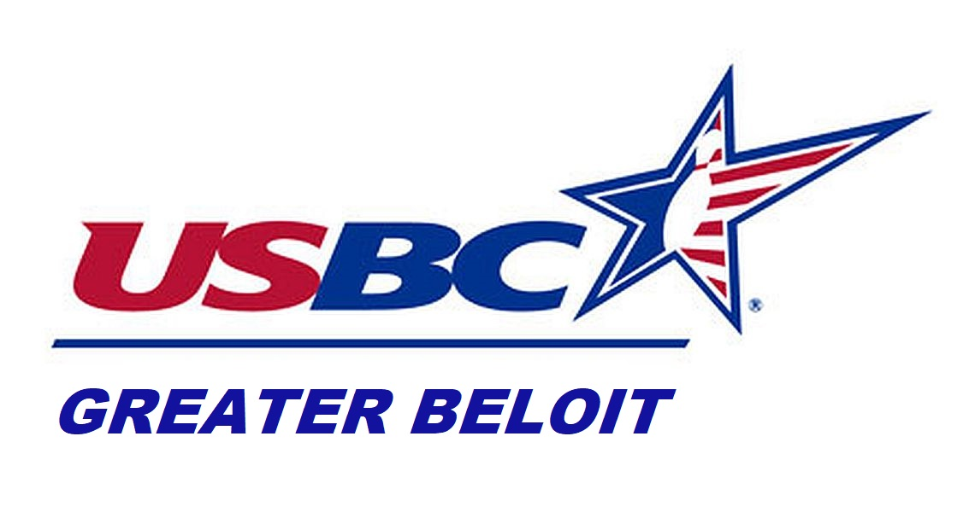Greater Beloit USBC Bowling Association – USBC Certified
101st Annual Open City Championship
Sponsored By: TRASH BOX DISPOSAL
Handicap base 90% of 225 Teams based on Average.
Prize fund Paid Back 100%
Team Event
Entry #

Squad #

Apr 10th, 11th, 18th, 25th

(1) Fri, Apr 10th 6:30 PM (2) Sat Apr 11th 6:30 PM

(3) Sat, Apr 18th 1:00 PM (4) Sat, Apr 25th 6:00 PM

*** Team events are allowed 3.5 Hours to complete event ***
SCR | HDC | Optional All-Events Scratch, HDCP, ($5.00 each)  Must Be Paid for Before Bowling Team Event  **Team Event will be a 4-Person Team**  Print Bowler’s Names | Bowlers ID Number | Average

1
2
3
4
Team Captain, I hereby enter the named team in the events indicated and agree to abide by the tournament rules and regulations of the Greater Beloit USBC.
Team Name__
Captain’s Signature

Tournament Co-sponsors



Squad #

Entry #

Singles & Doubles Event
Apr 18th, 19th 24th, 26th

(5) Sat, Apr 18th 6:00 PM (7) Sun, Apr 19th 12:00 noon

(6) Fri, Apr 24th 6:30 PM (8) Sun, Apr 26th 12:00 noon

*** S&D event is allowed 4.0 Hours to complete event ***
All Bowlers Entering the Doubles Event must also bowl Singles Event
Print Bowler’s Names Singles/Doubles
1
2
1
2

Team Event  $25.00 per Bowler  $100.00 Per Team  Prize Fee $60.00  Lineage & Expense $40.00 | Doubles/Singles Event  $25.00 per Bowler  $50.00 Per Team  Prize Fee $30.00  Lineage & Expense $20.00 | Singles Event  $25.00 per Bowler  Prize Fee $15.00  Lineage & Expense $10.00
Entry and payment can be made on our website Greaterbeloitusbc.com or they can be turned into Viking Lanes. (Dave Cliffe or Counter)

 **Ball Raffles Brought to you by the brands of Brunswick**

Tournament Rules

- All rule numbers refer to Tournament Rules in the USBC Playing Rules book. Any rules not covered in this document will be governed by the USBC tournament rules.
- Lane assignment for each event will be random computer assigned. Doubles will bowl together based on team event roster.
- Entries will be open to all current USBC membership. (Rule 300c) Bowlers not sanctioned through Greater Beloit USBC will have a $10.00 Participation Fee.
- The Open tournament shall consist of a (4) four-person team event and a doubles/singles event. There will be no limit to the number of times a team may participate in the team event, but 1 bowler must change to cash multiple times. An entrant may participate in the doubles/singles event multiple times. One of the doubles partners must change to cash multiple times. Singles will be paid the highest cash only.
- Optional All Events: The fee for participating in All-Events must be paid before the first event bowled. 100% of the All-Events prize fund will be returned. The bowler’s first appearance in each event counts toward the all-events total. (Rule 315d)
- Averages: a) Bowlers will use their highest USBC average from the previous season ending July 31. Bowlers having no previous season book average will use their highest current season average as of date of bowling. If the current average, (as of date of bowling), is 10 pins or higher than the prior season’s average then that current average must be used. b) All averages are based on 21 games. C) Bowlers not having an average per rule a) or b) will bowl at a 225-scratch average.
- Each bowler is responsible for submitting their own average. (Rule 319a) The average of any bowler may be adjusted before participation in any event or before payouts are made. (Rule 319e, Tournament Average)
- Any bowler arriving late will be permitted to bowl and their score will count beginning in the frame in which they enter the game. No score (0) will be given for frames missed. (322a)
- Any entrant violating tournament rules may be disqualified from the tournament and entry fees will not be returned. (Rule 314)
- Any protest affecting eligibility or general playing rules must be confirmed in writing to the association tournament committee before tournament prize payments are made. (Rule 329) Errors in scoring must be reported to the tournament director within 24 hours.
- All entries close 1 hour before the start of the last squad, depending on lane availability.
- COVID19 Rule - Any squad may be cancelled. Bowlers will have the option to bowl if the squad is rescheduled. If the tournament is stopped due to Covid19 or equivalent the tournament director has the option to end the tournament and adjust the prize list to the number of teams that have already bowled in an event. All entry fees will be refunded for any entries that have cancellations.
- Prize fees will be returned 100% in prizes within each event. (1 in 5) or better cash.


210 Oak Grove Ave, South Beloit, IL 61080

Entry and Payment can be made at Greaterbeloitusbc.com.
Dropped off entries At Viking
Make Checks Payable to:
Greater Beloit USBC
$35.00 Fee for NSF

Tournament Manager
Karson Schumacher

